BOOK ME
Need To develop clean website design professional Website for Travel Market Place
Some Competitors websites are here as a reference
1-https://www.transfeero.com/en/
2-https://www.hoppa.com/en
3-https://www.holidayautos.com/
4-https://www.mozio.com/en-us/
5-https://www.jayride.com/
6-https://city-airport-taxis.com/
Our Booking Form
https://booking.hypersoftwares.com/bookme
CURRENT
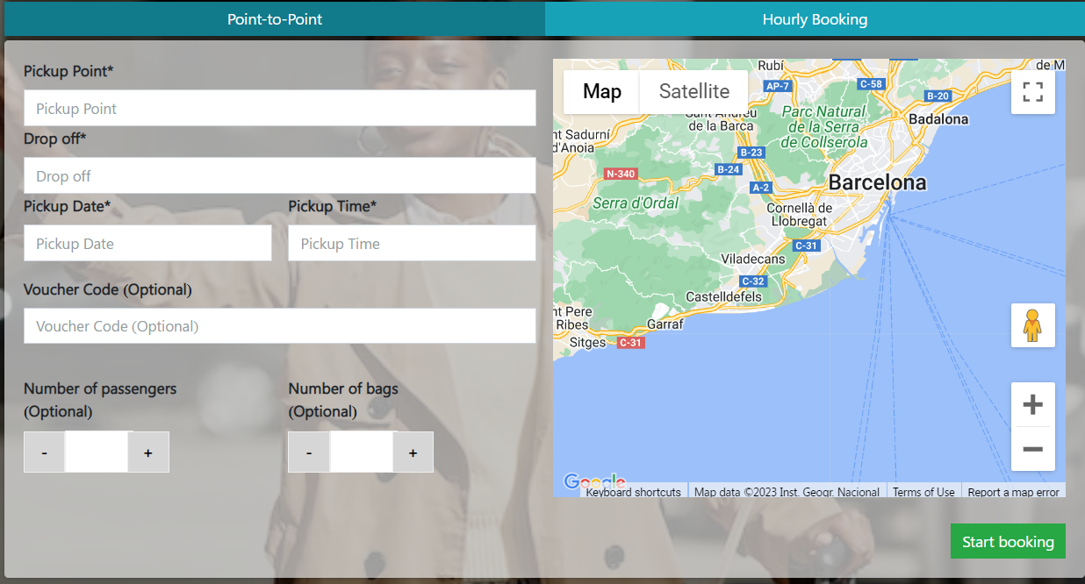

- Make Date & Time At same place for reference you can visit website: https://www.hoppa.com/en
When To select Date next ask for Time Also for return Trip just click on Add Return so there come for select return date and time so it’s nice.
Its example you can make its better design and latest style if you think that is best because this ref website is old so we are doing now so our style and design should be more updated and attractive

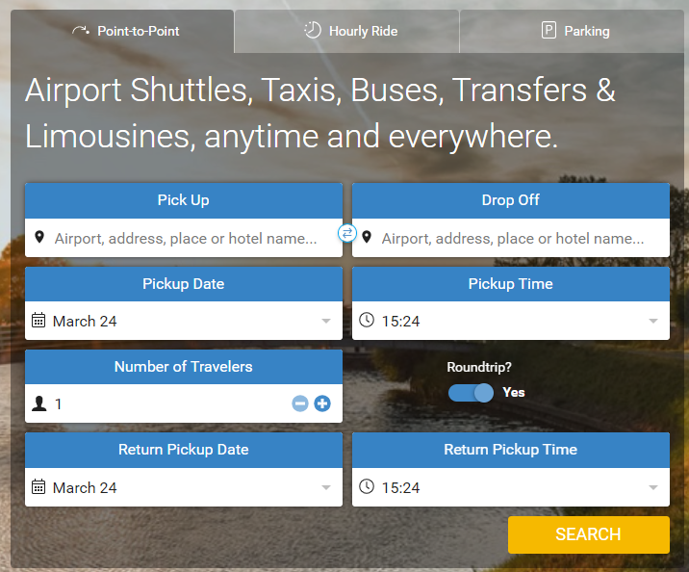
This is from another website where can hide and show round trip

So, In our bookme form we need to add option for return trip and remove Voucher code and number of bags
Because voucher he can use at the end time of payment

Next Steps
Display search requested data from server database
All Available Option from all suppliers for that requested ride
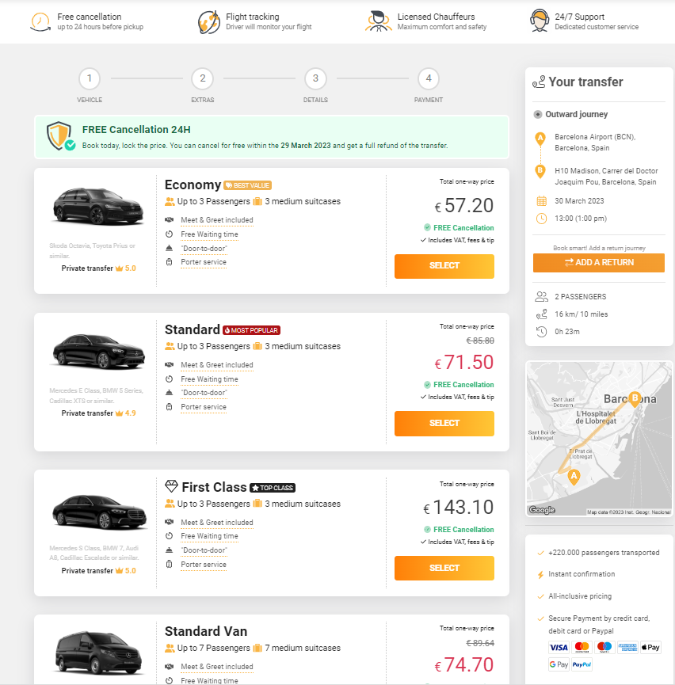

Once Client will Select His required Vehicle Next Step for select EXTRA OPTION
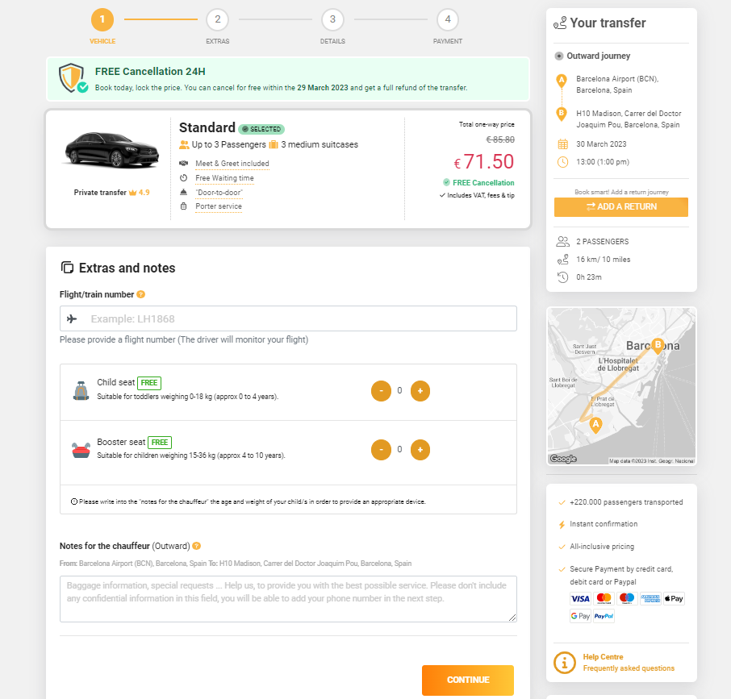

Here we can add Option for Add extra like Child Seat/Boster/pet/simcard/extra thing we can be chargeable and free also flight number and Note for chuffer

Next step if customer data
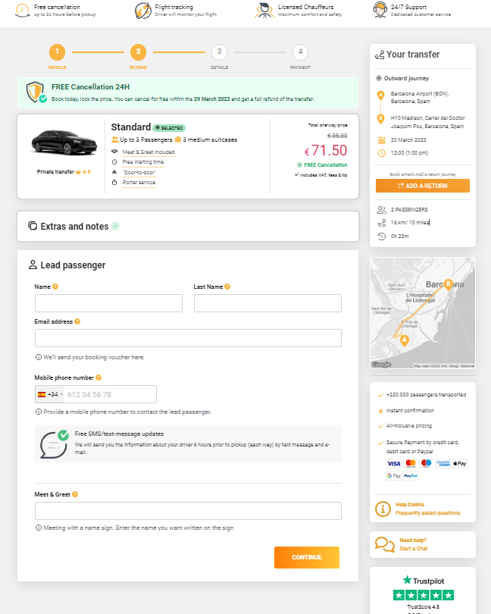
Here we will ask from customer Lead Guest Name and email phone number
And meet and greet
NEXT IS PAYMENT AND CONFIRMATION

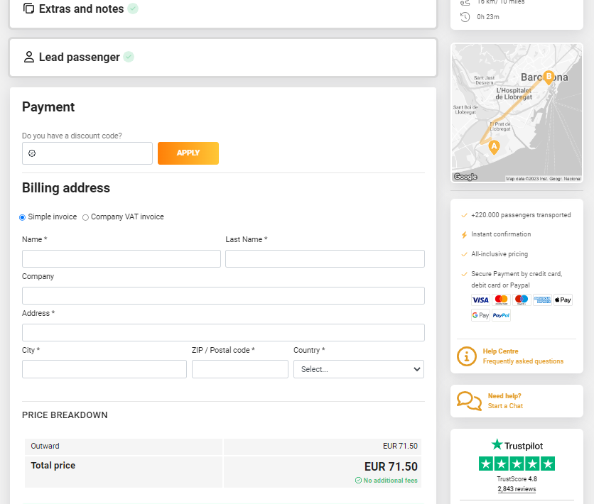

After Payment Complete BOOKING WILL GO SUPPLIER BOOKINGS then he have to Accept that booking after supplier accepted booking Customer will received confirmation voucher of his trip by email
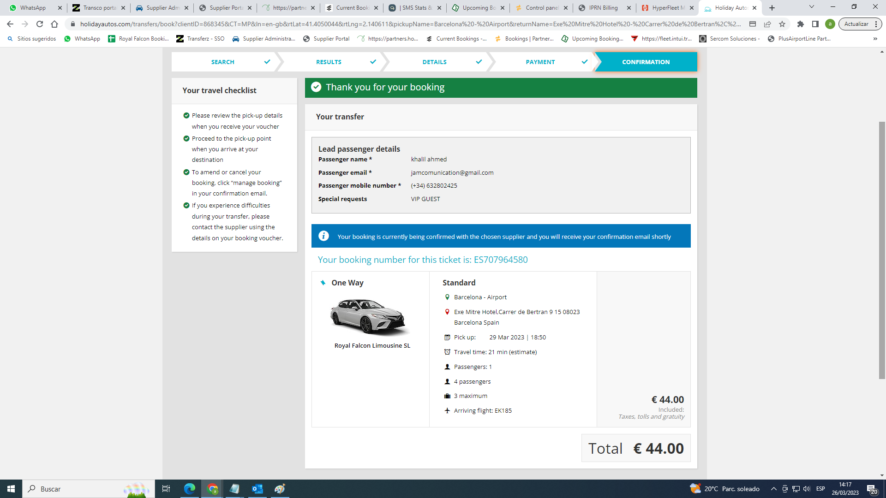
Client Payment made booking sent to supplier
Supplier decline booking saying no availability
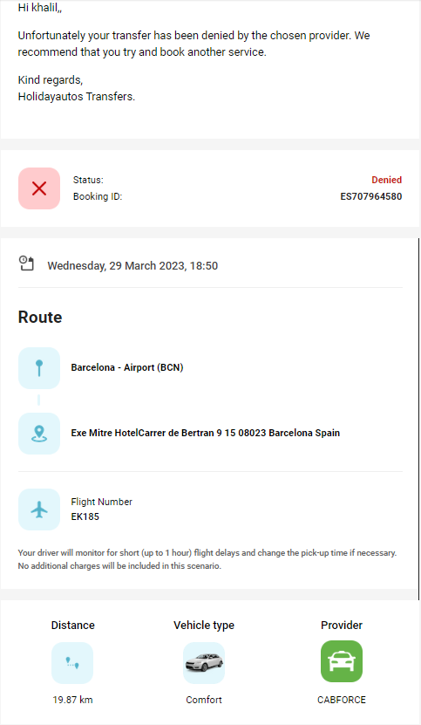
Client Not get charged until confirmation from supplier side

Until Supplier Not accept booking customer will not get his confirmation for this trip

